SmartPlant 3D v7
Orthographic Drawings Extraction Training

Table of Contents
Overview 1
Drawings Task Configuration 2
Setting up for batch process 2
Setting up the Error Log 2
Enable Excel to run Embedded Reports 3
Setting up Space Folders in WSE 4
Volume Drawings Workflow 5
A. Creating and Adding Surface Style Rules 5
B. Adding Piping Plan Drawing 7
C. Placing the Drawing Volumes 7
D. Updating the documents 11
Composed Drawing Workflow 12
A. Creating the Component and Drawing 12
B. Placing the Views 13
C. Associating the Volumes to Views (unable to confirm volume to be linked to view) 14
D. Updating the Drawing 16
Snapshot Drawings Workflow 17
A. Creating a Default View Style 17
B. Creating a Compose Drawing Type 18
C. Snapshot the views(crashing @ step 11) 20
D. Composing the drawing 22
E. Updating the documents 22
Drawings by Query Workflow 23
A. Using a Predefined Package (User Workflow) 23
B. Creating a DBQM Package (Admin Workflow) 24
Microstation 3D DGN Workflow 28
3D Model Data (SmartPlant Review) Workflow (hangs) 30
Setting Drawing Properties 31
Search Folders 32
Placing manual annotation 35
A. Manual labeling 35
B. Dimensioning 35
C. User Text 36
Editing Border Templates 38
Creating New Template 38
Using a DWG/DGN template to seed a drawing template 40
Adding Drawing Property Labels 40
Basic View Styles 42
Creating a volume view style 42
Creating a snapshot view style 43
Creating a key plan view style 44
Creating a volume drawing package 47
A. Creating the package 47
B. Testing the package 49
Defining Line Styles 51
Graphic Rules 53
VHL Rule 53
Replace with Line Rule 54
Replace with Line and Widget 54
Replace object with symbol 55
Defining Drawing Labels 57
Label Template 57
Label Symbol File 60
Label XML File 61
Creating Label Rule 62
Custom Graphic Rules 63
CappedNormalPipe.dll 63
DesignEquipmentPartSeparator.dll 63
ElbowtoArc.dll 64
ElbowtoSingleArc.dll 65
EquipmentNozzleSeparator.dll 65
GridlinesDrawingWrapperEntity.dll 65
MakeDrawable.dll 66
PipeTurnFeattoArc.dll 67
PortsSeparator.dll 67
ReplaceWPoint.dll 68
SlopedPipeWArcSymbol.dll 68
VolumeWireFrame.dll 68
Advanced View Styles 70
Deconstructing the piping plan view style 70
Analysis of drawings for view style creation 70

Overview
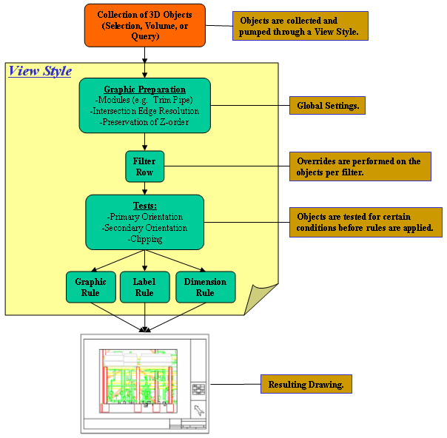

Drawings Task Configuration

Setting up for batch process
Complete these steps on the Batch Server computer and on all clients using batch processing. The instructions below are for Windows XP.
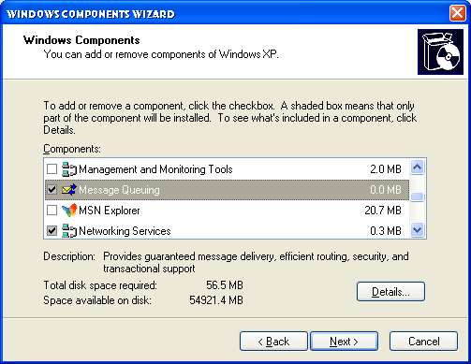
- Install the Microsoft Message Queuing component on your computer by clicking Control Panel > Add/Remove Programs.
- On the left side of the dialog box, click Add/Remove Windows Components.
- On the Window Component Wizard dialog box, select the Message Queuing box, and click Next. A status dialog appears while Windows XP starts the Message Queuing component.
- Click Finish. Microsoft Message Queuing is running on the computer.

Setting up the Error Log
Edit Registry key (Launch regedt32 at command prompt):
HKEY_LOCAL_MACHINE\SOFTWARE\Intergraph\Applications\Environments\Drawings\ErrorLog.
Set the Level value to 300 by double-clicking on the word “Level”
Level 1 will capture only errors deemed fatal
Level 300 will capture more data useful for diagnosing problems
It may be useful, though not required, to reset the %TEMP% env variable to a common temp location such as D:\TEMP\

Enable Excel to run Embedded Reports
If using Excel 2000, make sure SP3 is loaded.
If Excel XP or Excel 2003, open MS Excel and check the box under Tools – Macro – Security – Trusted Publishers – Trusted Publishers for Trust access to Visual Basic Project as shown:
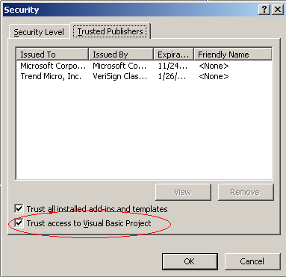

Setting up Space Folders in WSE
- In SP3D, on the menu bar, select Task > Space Management.
- While in Space Management, on the far right side of the screen you will find the Workspace Explorer console. On the Workspace Explorer console, select the “Space” tab.
- On the vertical tool bar on the left side of the screen, select the “Create Space Folder” button , which is the second button from the top.
- When this option is activated, you should see the following on the active ribbon bar:
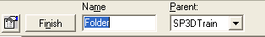
- In the text box labeled “Name”, type in “GA Drawings” and select the Finish button. This will place the space folder “GA Drawings” as a child folder to the parent folder “SP3DTrain”. Notice when you select finish, this places this folder under the “SP3DTrain” folder in the Workspace Explorer on the Space tab.
- With this command still active, on the ribbon bar, change the Parent folder to “GA Drawings” by dropping down the select list and choosing “More”. This will show you all the folders in the hierarchy on the “Space” tab of Workspace Explorer.
- With “GA Drawings” selected as the Parent folder, in the “Name” Text box, type “U01 and U02” and select the Finish button. Notice now that the folder “U01 and U02” has been placed under the folder “GA Drawings”.
- Likewise, create two more folders under “U01 and U02”. Name the first one “Drawing Volumes” and the second “Snapshot”.
- Once you have created the folders needed, you can either right click in the modeling workspace or select the “Select” tool on the vertical tool bar to exit the command.

Volume Drawings Workflow

A. Creating and Adding Surface Style Rules
Creating surface style rules enables you to change the look and feel of the objects the rules are applied to. Currently there is no rule applied to Drawing volumes, therefore the volume will display as solid gray. To create a new surface style rule to be applied to Drawing volumes, do the following steps.
- If you are not already in the Space Management Task, in SP3D, on the menu bar, select Task > Space Management.
- While in Space Management, select Format > Surface Style Rules from the menu bar. The following dialog will appear:
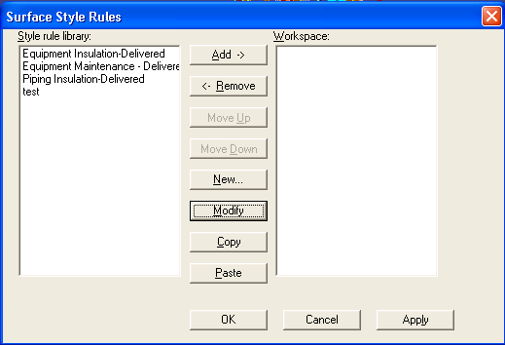
- Since we have no surface style rule for Volumes, we will need to create one. To do so, select the “New” button located in the center of this dialog box.
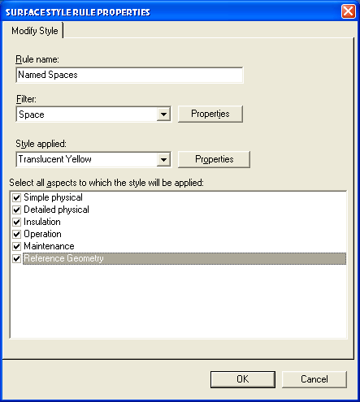
- In the “Rule Name” text box, type in “Named Spaces”.
- For the “Filter”, drop down the select list and choose “More”. This will open the “Select Filter” dialog where you will select: Catalog Filters > Default Filters > SP3D Object Filters > Object Types > Space (filter icon, not the folder) and click OK.
- Next you will apply the style applied to these volumes. Drop down the “Style applied” select list and select the “Translucent Yellow” style. Click OK to complete the creation of this Surface style rule. If the style rule already exists, modify it to the above parameters
- Notice now the new Style you created named “Named Spaces” in the Style rule Library on the left side of the Surface Style Rules dialog.
- To apply this newly created style, select the style from the left side of the dialog and click the “Add ->” button to move this style into the Workspace side. Highlight Named Spaces there and click Apply, then OK (failure to “Apply” will result in this style not getting used).

B. Adding Piping Plan Drawing
- Define workspace to “U01 & U02” from Training Filters.
- Switch to Drawings and Reports task
- Right mouse on the “SP3DTrain” Plant and select New…
- In the Add Component Dialog, from the General tab, select “Folder” and click OK.
- Right click on the newly created folder and select “Rename” and rename it to “GA Drawings”
- Right mouse on the “GA Drawings” folder and select New…
- In the Add Component Dialog, from the “Piping” tab, select “Imperial_Piping Plan”, and click OK.

C. Placing the Drawing Volumes
a. Place Drawing Volume by View
- Switch to the Space Management task.
- Open two graphics Windows and orient them to “Looking Plan” and “Looking North”. Hint: Use Common Views command
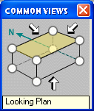
- Start pin-point.
- Start the Place “Drawing Volume by View” command 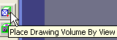
- In the ribbon bar, select “Piping Plan” for the Drawing Type. Drop down the select list for the Space Folder property and select the “Drawing Volumes” folder created earlier (may need to use more.. Database).
- In the pin-point toolbar, enter coordinates: E: 72’, N -2’, El –3’
- Click in a graphic view once. Next, the prompt will say: Place Second Pt
- Enter Elevation El 31’
- Click a view to place the volume.
- Place a second volume by entering pinpoint coordinates E: 72’, N 32’ 6”. El –3’ as prompt reads Place First Point
- Click in a graphic view.
- Enter Elevation EL 31’
- Click to place the second volume adjacent to the first one.
- Switch to the space tab of the Workspace Explorer to see that the two drawing volumes are created under the hierarchy of the drawing folders.
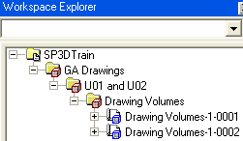
b. Place Volume by Selection
- Set a Window orientation to Isometric and close up to the frame shown in step 4 below
- Start the Place Drawing Volume by Selection command 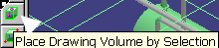
- In the ribbon bar, drop down the select list for Drawing Type and select
“More”. Navigate to the “Piping Plan” component and select OK.
Likewise, for the Space Folder property, drop down the select list for the
Space Folder property and select the “Drawing Volumes” folder from the
hierarchy and Click OK.
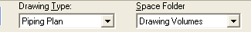
- Using the mouse pointer, select the objects shown in the figure below.
Notice as you click objects, the volume expands to include those objects.
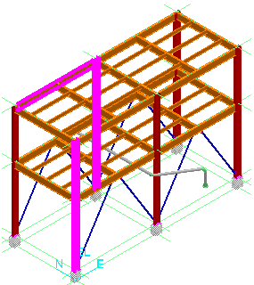
- After you have created the area for the volume, click Finish.
- Switch to the space tab of the Workspace Explorer to see that the three drawing volumes are created under the hierarchy of the drawing folders.

c. Place Volume by Two Points
- Fit all graphics in at least one Window
- In Space Management, start the Place Drawing Volume by Two Points command.
    - 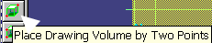
- In the ribbon bar, drop down the select list for Drawing Type and select
“More”. Navigate to the “Piping Plan” component and select OK.
Likewise, for the Space Folder property, drop down the select list for the
Space Folder property and select the “Drawing Volumes” folder from the
hierarchy and Click OK.
- Using pinpoint, for your first point enter E 50’, N 9’, EL 2’
- Click in the workspace to place your first point.
- To place your second point, using pinpoint, enter E 72’, N 26’ EL 30’ and click in the workspace to place the second point, which will create the volume.
- Switch to the space tab of the workspace explorer to see that the four drawing volumes are created under the hierarchy of the drawing folders.
d. Place Volume by Four Points
- In Space Management, start the Place Drawing Volume by Four Points command.
- 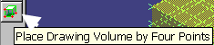
- In the ribbon bar, drop down the select list for Drawing Type and select
“More”. Navigate to the “Piping Plan” component and select OK.
Likewise, for the Space Folder property, drop down the select list for the
Space Folder property and select the “Drawing Volumes” folder from the
hierarchy and Click OK.
- Using pinpoint, for your first point enter E 72’, N 58’, EL 0’. This point will define your starting point.
- Click in the workspace to place your first point
- For your second point, enter E 72’, N 2’, EL 0’. This point will define your X-AXIS, based on the starting point to this point.
- Click in the workspace to place your second point.
- To place your third point, unlock the coordinates by clicking on the lock buttons beside the coordinate values and enter E 112’, N 2’, EL 0’. This point will define your Y-AXIS, based on the second point you placed to this point.
- Click in the workspace to place your third point.
- To place your fourth point, unlock the Elevation coordinate by clicking on the lock button beside the coordinate value and enter EL 30.5’
- Click in the workspace to place your fourth point. Notice when you click in the workspace, your volume is created.
- The five drawing volumes are created under the hierarchy of the drawing volumes folders

D. Updating the documents
- Switch to the Drawings and Reports task.
- Expand the tree to GA Drawings and right mouse click on Piping Plan.
- Select Create Drawings.
- Five drawings are created, select the first one, right mouse click and select “Update Now”. This takes about a minute.
- Open drawing to view it (double click).
- Continue by updating the remaining drawings and viewing them.

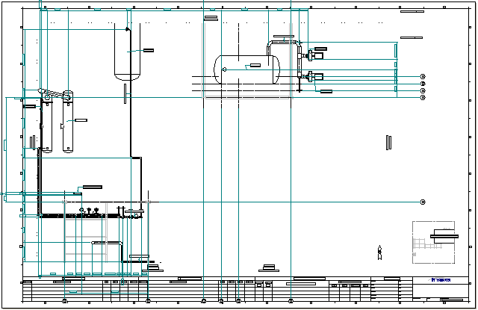

Composed Drawing Workflow
Composed Drawings can be created using a combination of commands available in the 3D tasks, the Drawings and Reports task and the 2D Drawing Editor. They can be created in the 3D Tasks, manage them in the Drawings and Reports task, and modify the templates and the drawing layout in the 2D Drawing Editor.
Composed Drawings can be created using Drawing volumes, Space Volumes and Snapshot volumes. In the lab below, the drawing volumes created in the previous lab will be used to create a Composed Drawing.

A. Creating the Component and Drawing
- If you are not already in the Space Management task, change to this task by selecting Tasks > Space Management from the menu bar of your current SP3D environment.
- In the Space Management task, select Tools > New Drawing. The following dialog will display: 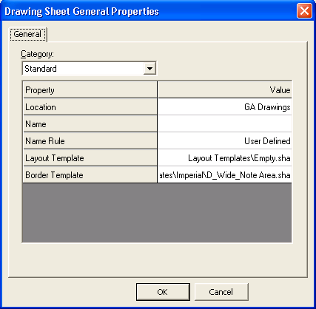
- For the “Location” property, drop down the select list and choose “More”. In the “Select Drawing Component” dialog select the “GA Drawings” folder and click OK. This will place a new component under the GA Drawings hierarchy in Drawings and Reports called “New Composed Drawings”.
- For the “Name” property, type in “Composed Drawings Lab”. This will be the name of the physical drawing created in the component created in step 3 above.
- For the “Layout Template” property, drop down the select list and choose “More”. In the “Select Template”, select the Empty.sha template and click OK.
- For the “Border Template” property, drop down the select list and choose “More”. In the “Select Template” dialog, double click the “Imperial” folder. Select the D_Wide_NoteArea.sha template and click OK.
- Click OK on the “Drawing Sheet General Properties” dialog, which will open the Shape2D drawing editor behind SP3D. Bring the Shape2D drawing editor up as the active application.

B. Placing the Views

- In Shape2d, fit the view and select the “Place View” command from the horizontal toolbar.
- With this command active, place the view in the drawing frame using a two point method. At the B1 position of the drawing frame, click once to place your first point. Drag the mouse to position F4 and left mouse click to place your second point.
- After the view is placed the “Drawing View Properties” dialog will display. On the View tab of this dialog, drop down the “Style” select list and choose “More”. This will open the “Select View Style” dialog. In the Orthographic folder, select the “Structural Framing Plan” view style and click OK.
- Notice, after the view style is selected, more options appear for the definition of this view. It will look as follows:
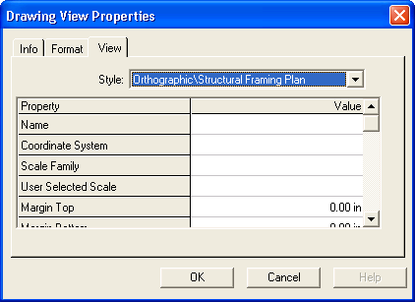
- For the “Name” property, type in “View1”.
- For the “Scale Family” property, drop down the select list and choose “Fit to Scale”.
- Scroll down in this dialog and locate the property “Look Direction”. This field should be set to “Looking Plan”. If it is not, do so by dropping down the select list in the “Value” column and set the this property to “Looking Plan”.
- Click OK on the “Drawing View Properties” to save and close this dialog. Once this dialog is closed the drawing template will save the changes automatically made to the template up to this point.
- Place another view, where the first point of the view is placed at B5 and the second point at F8.
- Again, set the View style to “Structural Framing Plan”.
- “Name” this view “View2”, set the “Scale Family” to “Fit to Scale”, and make sure the “Look Direction” is “Looking Plan” and click OK on the “Drawing View Properties” dialog. Again, the changes will be save to the template.

C. Associating the Volumes to Views (unable to confirm volume to be linked to view)
- After placing the views, the volumes will need to be associated to them. Choose the first view placed (View1), by left mouse clicking on the border of the view, and select the “Associate Objects to View” command located on the horizontal toolbar.
- With this command active, go back to SP3D, which should be open behind the Shape2D drawing editor and notice the ribbon bar in SP3D. The ribbon bar should look as follows:
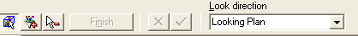
For View1, select the volume placed in a previous lab as shown below: 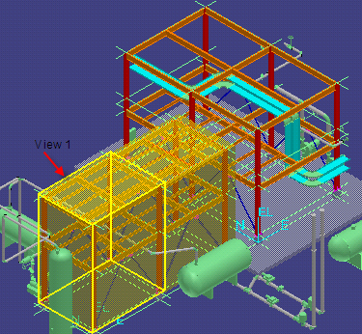
- With this volume selected, click the “Accept” button on the ribbon bar. This has associated this volume with the view select in Shape2D drawing editor. Select “Finish” to complete the association.
- Make the Shape2D drawing editor window the active window again. Select the “Select” button to deactivate the previous command.
- Choose “View2”, by left mouse clicking on the border of the view, and select the “Associate Objects to View” command located on the horizontal toolbar as done in step one of this lab.

- For View2, select the volume placed in a previous lab as shown below: 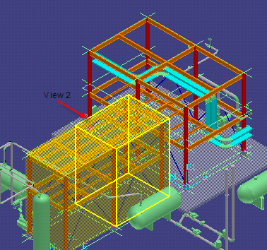
- With this volume selected, click the “Accept” button on the ribbon bar. Select “Finish” to complete the association.
- Go back to the Shape2D drawing editor and close the application.

D. Updating the Drawing
- Change to the Drawings and Reports task by selecting Tasks > Drawings and Reports from the menu bar of your current SP3D environment.
- Navigate to the new component created in the “GA Drawings” folder in the Management Console and select it. The new component will be named “New Composed Drawings”.
- Notice the drawing created named “Composed Drawing Lab”. Right mouse click on the drawing and select “Update Now”. 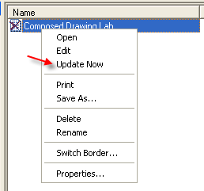
- When the drawing is Up-To-Date, double click the drawing to view the results.

Snapshot Drawings Workflow

A. Creating a Default View Style
- If you are not already in the Drawings and Reports task, do so by selecting Task > Drawings and Reports from the menu bar.
- In Drawings and Reports, select Tools > Define View Style. The following dialog will appear:
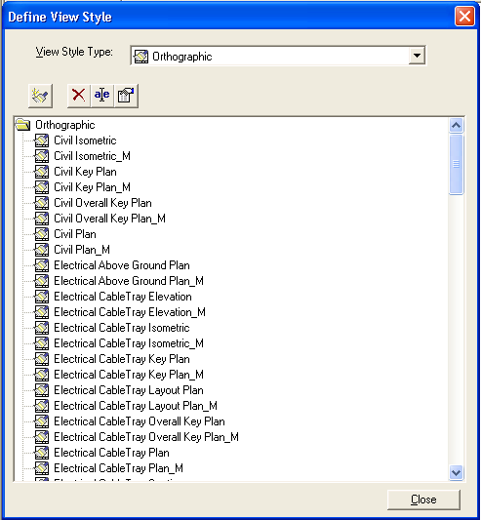
- In the “View Style Type:” drop down list, select the Orthographic option.
- To create a new style for snapshot drawings, select the “New Style” button. This will create a new style in the list of orthographic view styles. Rename this style to “Default1”.
- To view the properties of this style, either double click the new style created or select the properties button , while the style is highlighted. The following View Style Properties dialog will appear:
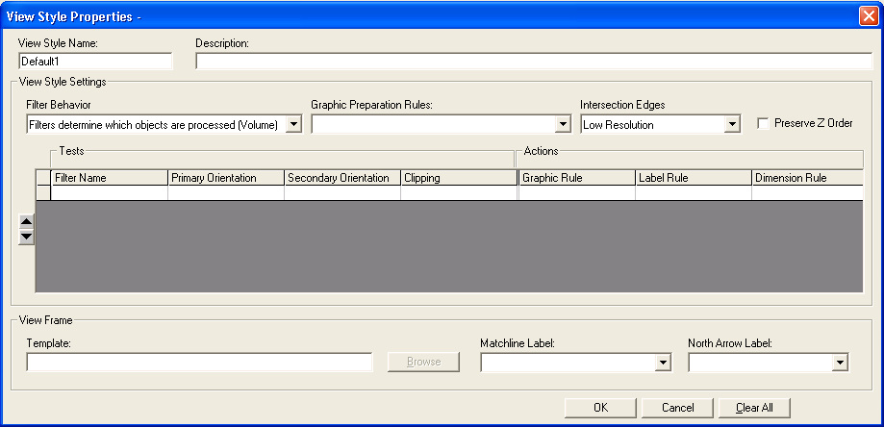
- For the “Filter Behavior” drop down list, select “Filters provide overrides to set of objects (Snapshot)”. Click OK to accept changes and close this dialog.

B. Creating a Compose Drawing Type
Snapshot drawings are placed on a drawing component called Composed Drawings. This component can be created in one of two ways.
a. Creating Drawing component in Drawings and Reports
  - Right mouse on the GA Drawings folder under the Plant and select New…
  - In the Add Component Dialog, from the General tab, select “Composed Drawings”
  - Rename the newly created drawing type to “Snapshot Composed Drawings”
b. Creating Drawing component in Modeling Task
- Go into the Common Task by selecting Task > Common from the menu bar.
- In the Common Task, select Tools > New Drawing from the menu bar. The following Dialog will appear:
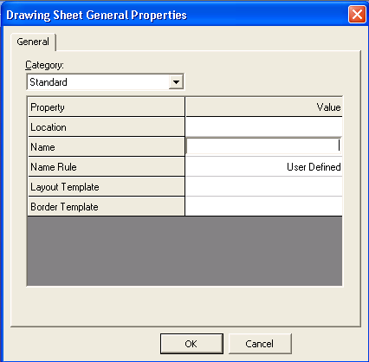
- For the Property “Location”, drop the list down in the “Value” column and select “More”. This will display the hierarchy created in the Drawings and Reports task. Navigate to and select the GA Drawings folder and click OK.
- For the property “Name” type in “Snapshot”. This field will define the name of the drawing in the Drawings and Reports task.
- For the property “Layout Template”, drop the list down in the “Value” column and select “More”. Currently, there is only one pre-defined template “Empty.sha”. Choose this template.
- For the property “Border Template”, drop the list down in the “Value” column and select “More”. On the “Select Template” dialog, double click the Imperial folder, which will extend the list, select the D_Wide_Note Area.sha as the border template and click OK. This will create a new component in Drawings and Reports, under GA Drawings, named “New Composed Drawings”.
- Click OK on the Drawing Sheet General Properties dialog. This will open the Shape2D drawing editor application, containing the template chosen in the previous step, allowing you to place views. Since we have no Snapshot views to place on the template, we must create these views in SP3D. Leaving the Shape2D application open behind SP3D, proceed to the next lab.

C. Snapshot the views(crashing @ step 11)
  - While in the Common task, redefine the workspace to be Plant Filters > Training Filters > U01.
  - Set the 3D view orientation to iso and fit the graphic view.
  - Clip the view to all elements using clip by object command. To do this, using the mouse, click and hold the left mouse button in the modeling space, and fence in all objects from U01 as follows:
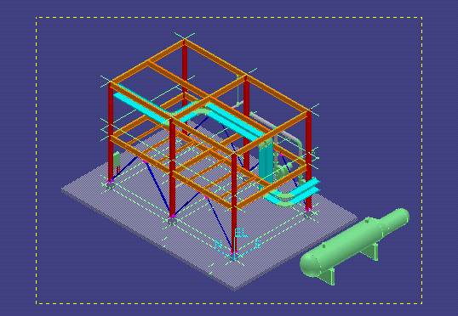
When you release the mouse, all objects will highlight in a magenta color scheme. With these objects selected, activate the “Clip By Object” command , located on the horizontal toolbar. This is done to restrict the Snapshot view to only the objects to be drawn and eliminate extra whitespace. To get out of the “Clip By Object” command, right click twice in the modeling space.

  - Select Tools > Snapshot View. Once this command is active, you will be presented with the following ribbon bar:
  - For the “Drawing type” field, drop down the select list and choose “More”. This will open the Hierarchy in Drawings and Reports. Navigate to GA Drawings and select “New Composed Drawings”. Click OK.
  - For the “View name” field, type in “Iso”.
  - By typing in the View name, the next field, “Naming rule”, will default to “User Defined”.
  - For the “View Style” field, drop down the select list and choose “More”. This will open the dialog “Select View Style”. Select the “Default1” view style, created in a previous lab and click OK.
  - For the “Space Folder” field, drop down the select list and choose “More”. The “Select Space Folder” dialog will open. Navigate to GA Drawings and select U01 and U02 > Snapshot and click OK.
NOTE: This defines where, on the Workspace Explorer Space tab, this view will be stored for future use.
  - Once these fields have been populated, click the “Finish” button on the far left of the ribbon bar.
  - Set the 3D view orientation to North and fit the graphic view (or make the North view the active view)
  - Snapshot another view named “North”.

D. Composing the drawing
- Set the Shape2D drawing editor application as the active window on the desktop.
- In Shape2D, select the “Place Snapshot View” button located on the horizontal toolbar. This will activate a new ribbon bar as follows:
- For the “View Name” field, drop down the select list and notice that only the two views that were created in the previous lab are displayed. Select the view named “Plan” for this field.
- For the “View Style” field, the style defined while placing the view is remembered and will be the style used. In this case, we are using the Default1 view style created in a previous lab.
- For the “View Scale” field, the “Fit to Scale” option is defaulted, which is what will be used in this example. To view the available scale families, simply drop down the select list.
- Once these fields are populated, place the view in the drawing frame using a two point method. At the A1 position of the drawing frame, click once to place your first point. Drag the mouse to position G4 and left mouse click to place your second point.
- Similarly place the North view on the same drawing where point one is at A5 and point two is at G8.
- Once these views are placed, the document will automatically save. Close the Shape2D drawing editor application.

E. Updating the documents
- Go into the Drawings and Reports task by selecting Tasks > Drawings and Reports.
- Expand the GA Drawings folder and click on the New Composed Drawings component in the Management Console. Notice, under this component, the drawing “Snapshot” created in a previous lab.
- Right click on the drawing “Snapshot”, and select “Update Now”.
- After about 1-2 minutes the drawing is updated. Right click on the drawing “Snapshot” and select Edit to view the output of the drawing.

Drawings by Query Workflow

A. Using a Predefined Package (User Workflow)

- In Drawings and Reports task right-click on GA Drawings and select New…
- In the “Add Component” dialog, on the General tab, select Drawings by Query Manager and click OK
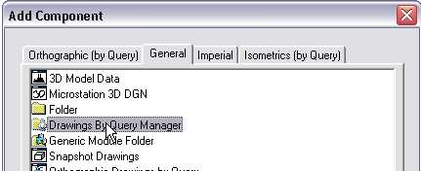
- Right click on the Drawings By Query Manager component that was just added to the Management Console and select “Rename”. Rename this component to “Pipe Support Drawings”
- Right click on Pipe Support Drawings component and select Setup…
- For the “Filter” property, drop down the select list and choose “More”. In the “Select Filter” dialog select the U01 filter from Plant Filters > Training Filters > U01.
- For the “Package” property, drop down the select list and choose “More”. In the “Select Package” dialog, select “Pipe Support Drawings” and click OK
- On the “Setup” dialog, click OK to save and exit the setup.
- Right-click on the “Pipe Support Drawings” component and select “Run Query”. Wait till the tree is automatically created.
- Right-click on the lower Pipe Support Drawings node and Create Drawings
- Right click on the drawing PS-01 created in the Detailed View and select “Update Now” (HANGS!)

B. Creating a DBQM Package (Admin Workflow)
- In Drawings and Reports Task, right-click on GA Drawings and select New…
- In the “Add Component” dialog, on the General tab, select “Orthographic Drawings By Query” and click OK.
- Right click on the “Orthographic Drawings” component created in step 2 above and select “Rename”. Rename this component to “Drawing Volumes by Query”.
- Right click on the “Drawing Volumes by Query” component and select “Setup”.
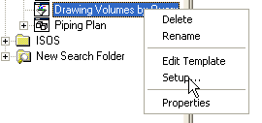
- For the property “Filter”, drop down the select list and select “More”. In the “Select Filter” dialog, navigate to Catalog Filters > Default Filters > SP3D Object Filters > Object Types > Space > Space Entities: and select the Drawing Volumes (do not select the Drawing Volumes folder) and click OK.
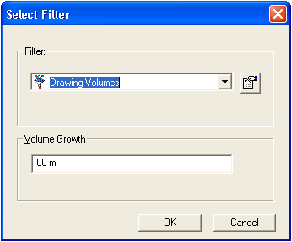
- Click OK on the “Select Filter” setup dialog to save and exit the setup.
- To setup the drawing template, right click on the “Drawing Volumes by Query” component and select “Edit Template”. This will open the Shape2D drawing editor.
Select template dialog appears. Pick D Wide Note Area.sha.
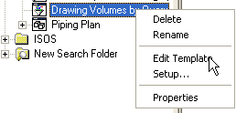
- On the horizontal toolbar, select the “Place Drawing View” command .
- To place the view using two points, left mouse click at position B2 in the drawing frame and drag the mouse pointer to position G7 and left mouse click again. This will place the view and open the Drawing View Properties illustrated below:
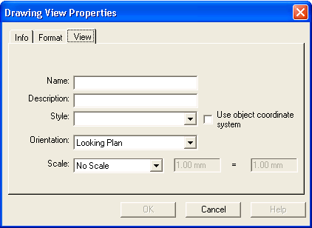
- For the “Name” property, type in “Volume”.
- For the “Description” property, type in “Volume”. This field is not required to contain data.
- For the “Style” property, drop down the select list and select “More”. In the “Select View Style” dialog, choose the Structural Framing Plan view style and click OK.
- For the “Orientation” property, the defaulted value that is supplied is the “Looking Plan” orientation. For this exercise, leave this value as the Orientation.
- For the “Scale” property, the defaulted value that is supplied is the “No Scale” scale. For this exercise, leave this value as the Scale.
This dialog should look as follows:
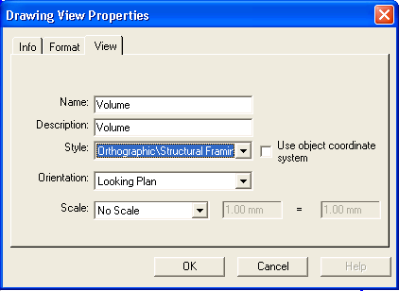
- Click OK to save and exit the Drawing View Properties dialog.
- Exit out of Shape2D drawing editor and when prompted to save, choose “Yes”.
- Now that the query is setup and the template has been created, the package needs to be saved. To save this component as a package, right click on the “Drawing Volumes by Query” component and select “Save package”. PACKAGE NOT GETTING SAVED
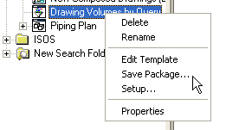
The following Save Package dialog will appear:
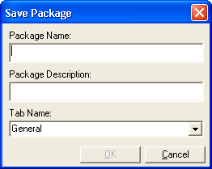
- For the “Package Name:” property, type in “Volumes by query”.
- For the “Package Description” property, type in “Drawing Volumes”.
- For the “Tab Name” property, drop down the select list and choose “Orthographic (by Query)”. Click OK to save the package.
- Redo Section A (Using a Predefined Package) using the package defined in this lab (Volumes by query)

Microstation 3D DGN Workflow
- Right-click on GA Drawings and select New..
- From the Add component dialog, select Microstation 3D DGN from the General tab
- Right-click on New 3D DGN Drawings and click Setup…
- Verify that the style is set to 3D DGN (NOT LISTED AS A DEF STYLE..)
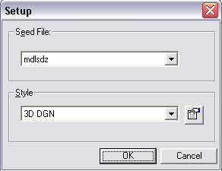
- Switch to the Space Management task
- Start the Place Drawing Volume by Selection command
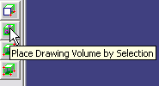
- On the ribbon bar, pick ‘New 3D DGN Drawings’ in the Drawing Type field and click OK.
- Select the slab, one of the top beams and one of the pumps as shown
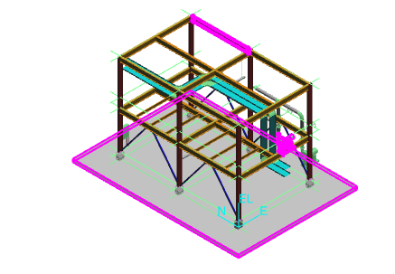
- Click Finish to create the volume
- Switch to Drawings and Reports task, create drawing and update. Wait while MicroStation is opened and closed.
- Double-click the drawing to open and view the output 3D DGN file.

3D Model Data (SmartPlant Review) Workflow
  - Right-click on GA Drawings, select New… and add a New 3D Model Data component from the General tab
  - Right-click on 3D Model Data and Setup…
  - Pick the Unit 1 filter in training filters and click OK
  - Set the Paths to a temporary training folder on your workstation and OK
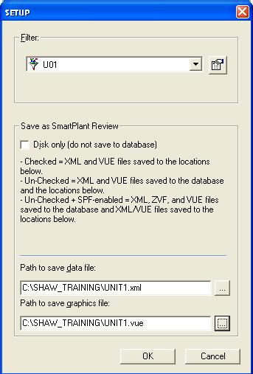
  - Create Drawing then Update Now (NOTE: EF SCHEMA COMPONENT NEEDS TO BE INSTALLED FOR THIS TO WORK) (HANGS)
  - Double-click the Unit1.vue file to open and review it in SmartPlant Review if available.

Setting Drawing Properties
Exercise:
- Select the Plant parent level in the hierarchy, right click, and select “Properties”. Add values for the following attributes, Click the field to update and type:
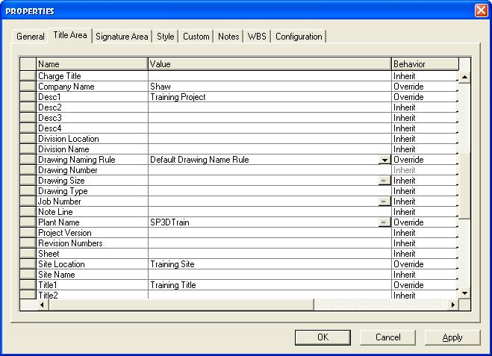
- OK the form to save the Plant level attributes.
- Right click on the “GA Drawings” folder, select “Properties” and review the Title Area attributes. Note that the Plant level attribute values have been applied to the GA Drawings folder.
- Edit the Title 2 text for GA Drawings properties to read ‘GA Drawings Level Data’
- OK the form and exit.
- Reselect the Plant root level, right click, and select “Properties”. Change the Title 1 attribute string to read “Plant Level Data”. OK and exit the form.
- Select the GA Drawings folder, right click, select “Properties”. Note that the Plant Level attribute for Title 1 has automatically changed to “Plant Level Data” in Drawings GA as changed above.
- Similar attribute behavior is seen for all plant folders, snap-ins, and items (drawings, reports, or isos).

Search Folders
The “Search Folder” component allows you to search for documents based on common properties such as out-of-date status, approval, or documents that have been published to a certain contract in integrated environments. You can create a Search Folder component in any folder in the Management Console. After running the query defined for a Search Folder, you can perform such tasks as Update or Publish as if you were working from the actual owning component location for the documents.
In this lab, we will create a Search Folder that will return all drawings that are out-of-date.
- While in the Drawings and Reports Task, Right-Click on the root component “SP3D Train”, then in the drop-down list Select “New”. 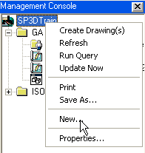
- From the “Add Component” dialog, on the General Tab, Select “Search Folder”, and Click OK.
- This will add a component called “New Search Folder” into the Drawings and Reports hierarchy. Right-Click on “New Search Folder” and Select “Setup”. 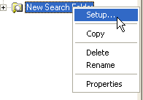
- In the Setup dialog, for the “Filter” property, choose “More”. This will bring up the Select Filter dialog. Click on the “Plant Filters” folder and select the “New Filter (Simple or Asking)” button on the horizontal toolbar.
- On the “New Filter Properties” dialog, type in “Search for Out-of-Date Volumes” for the “Name” property.
- Click on the “Properties” tab in the filter definition dialog.
- For the “Property” field, drop down the select list and choose “More”. This will open the “Select Properties” dialog.
- For the “Object type used as the basis for the property identification” property, drop down the select list and choose “More”. This will open the “Select Object type” dialog. Select the “Drawing Sheets” folder as follows and click OK:
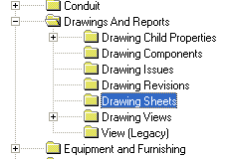
- With the “Relationship” property set to “Direct Property of Object Type” and the “Display properties in this category” set to “Standard”, scroll to the bottom of the list at the bottom of this dialog and select the “UpToDate” property, as follows, and click OK:
- 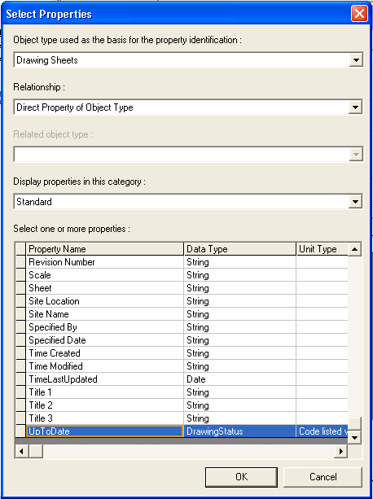
- For the “Operator” property, drop down the select list and choose “=”.
- For the “Value” property, drop down the select list and choose “Border Out Of Date”. The selection should look as follows:
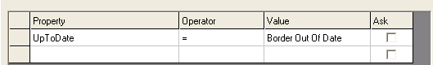
- Click OK to save and exit the filter definition.
- On the “Select Filter” dialog, select the filter that was just created and click OK, which will save and close out this dialog.
- On the Setup dialog, set the “Start From:” property to “SP3DTrain”. Click OK to save and exit this dialog.
- In the Management Console, right click on the “New Search Folder” and select “Run Query”.
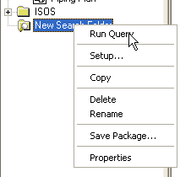
- This will return the drawings that meet the criteria in the filter definition.

Placing manual annotation

A. Manual labeling
- Select the DrawingNumber1 from the Snapshot drawing type, right click and select Edit.
- Zoom into the pumps in the plan view
- Select the place a label command
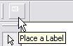
- Select one of the pumps
- From the pick list of labels, pick the Name_Rect_CA_JL label as shown
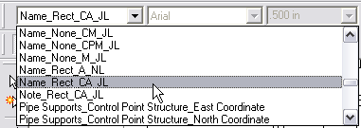
- Make sure the ‘As Drawn’ checkbox in the ribbon bar is checked.
- A label appears on your cursor, click in the sheet to place it where desired.
- Now select the other pump and label it.
- Right-click to exit the labeling command

B. Dimensioning
- Click the Dimension button in the main toolbar to open the dimensioning toolbar.
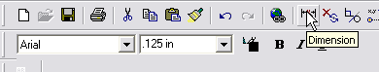
- Dock the dimensioning toolbar to the top of the screen and select the Distance between command
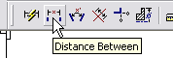
- Select two gridlines in the plan view by clicking them in succession as shown. A dimension appears on your cursor.
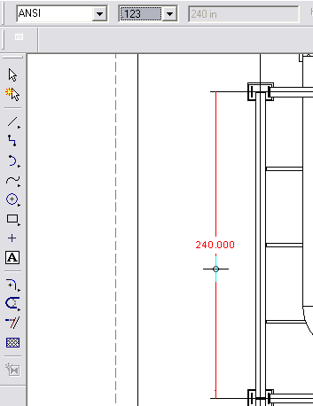
- Click to place the dimension where desired.

C. User Text
- Select Tools – Layers
- In the layer toolbar, key in UserText and press Enter. This will create a new layer named UserText and make it active
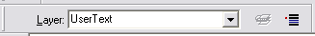
- Using the text command on the vertical toolbar, enter some text, e.g. the name of the view and place it under the view.
- Save and exit the drawing.

All of the manually placed text or graphic annotation on layers whose name starts with the letters ‘User’ is saved. All labels and dimensions are saved through updates.

Editing Border Templates

Creating New Template
- Open the Drawings Editor
- Select File => Properties => Units Tab. Set the file attributes as noted and select OK.
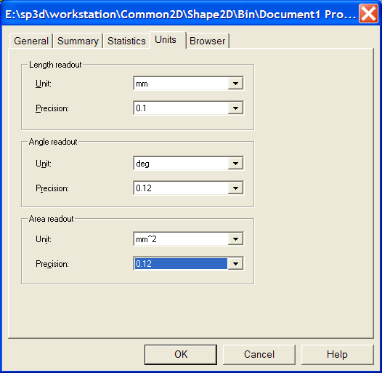
- Select File => Sheet Setup => Size and Scale tab. Set the file attributes as noted and select OK.
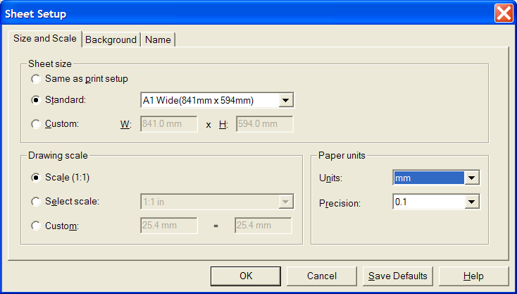
- Select File => Save as and save the file in the (\\[Symbol Share]\Drawings\Catalog\templates) as “New_A1_1.sha” and select “Save”.
- Save the file again, but this time as “New_A1_2.sha”.

Using a DWG/DGN template to seed a drawing template
- First determine the size of the template file you want to create.
- Open Windows Explorer and navigate to [Installation Dir]\Common2D\Shape2D\Template
- Select Normal.sha and view File Properties and uncheck the Read Only attribute.
- Open Normal.sha in Drawing editor and set its size to the desired size of your template. Save and close drawing editor.
- Open Drawing Editor using desktop shortcut.
- File – Open to open the DGN or DWG file, the file contents are automatically converted to SHA format. Scaling issues are avoided due to steps 1 through 4.
- Tools – Layers and create a layer called ‘DwgTemplate’
- Select all border graphics from all auto-created layers in the file and move them to the DwgTemplate layer using the Change Layer button on the Layers toolbar.
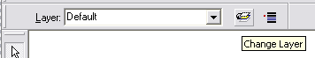
- Save the file in the [Symbol Share]\Drawings\Catalog\Templates directory with the desired name.

Adding Drawing Property Labels
- Enter the Drawings and Reports Task.
- Select Tools => Edit Border Template.
- Select “New_A1_2.sha” and OK the form.
- Select the Place Drawing Property Label command
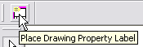
- In the Label Set pull down, pick Title Area
- In the Field pull down, pick CompanyName
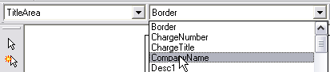
- Click close to the bottom right corner of the sheet to place the label
- Similarly pick the ApprovedBy field from the SignatureArea label set and place it as well.
- Save the template and exit Drawings Editor.

Basic View Styles

Creating a volume view style
- Tools → Define View Style
- In the View Style Type pick list, select Volume View Styles
- Click New to start creating a new view style.
- In View Style Name, enter Piping1 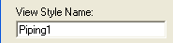
- In the first row of the grid, under Tests, under the Filter Name column, select More…
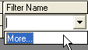
- Select the catalog filter under Catalog Filters\Default Filters\SP3D Object Filters\Object Types\Piping and select the filter named Piping Parts (not the folder with the same name).
- Under the Actions, under the Graphic Rule column, select More…
- Select New.
- In the Graphic rule – VHL dialog, set Rule Name: to Normal and Visible Line Style to Normal Red. Set description Visible:Normal Red.
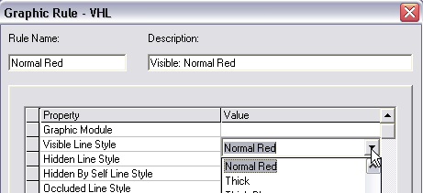
- Click OK to define the new VHL rule.
- Select Normal and click OK to apply the rule in the style.
- Under Matchline Label, select Matchline_None_A
- Click OK to define the view style.

Creating a snapshot view style
- Select Tools => Define View Style. Select “Snapshot View Style” from the pulldown on the form.
- Select “New”. The “View Style Properties - Snapshot” form appears.
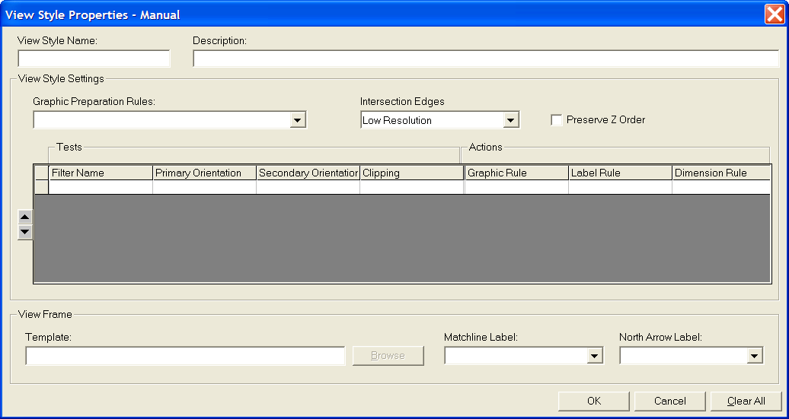
- Key in “Equipment1” for the View Style name and Description.
- Select the Filter Name => More… field. Select the catalog filter Catalog Filters\Default Filters\SP3D Object Filters\Object Types\Equipment and Furnishings and select the filter named Equipment.
- Select the Graphic Rule => More… field. The Select Rule form appears.
- Select the “Visible/Hidden Edges (VHL)” option from the pulldown list. And then Select “New”. The Graphic Rule VHL form appears.
- Key-in “Normal Blue” for the Rule name and Visible:Normal Blue for the Description.
- Select the “Visible Line Style” pulldown and select “Normal Blue”. OK the form.
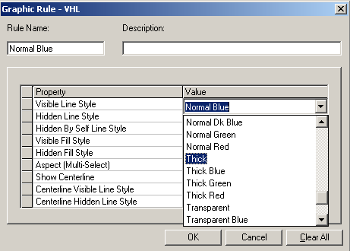
- Select the newly created graphic rule on the Select Rule form and OK the form.
- Similarly select Name_None_A_JL for the label rule.
- OK the form.
- You have now created a basic View Style for Snapshot Drawings.

Creating a key plan view style
- Select Tools – Define Key Plan View Style
- Select New… and name the view style ‘Plant view’
- Select All Objects as the range filter
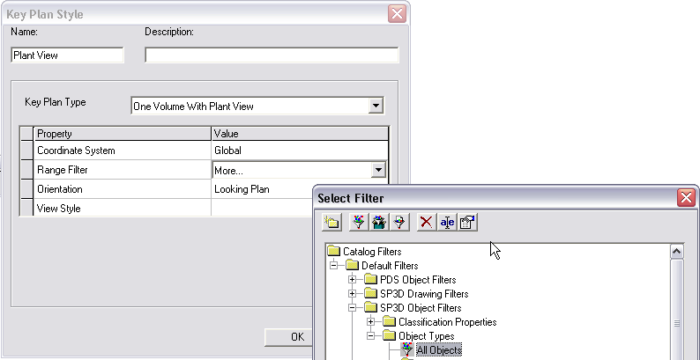
- For the View Style, select More…
- Switch to Volume View Styles and create a New View Style
- Name it ‘Key Plan Plant View’
- Select the filter for the first row to be ‘Grid Line’
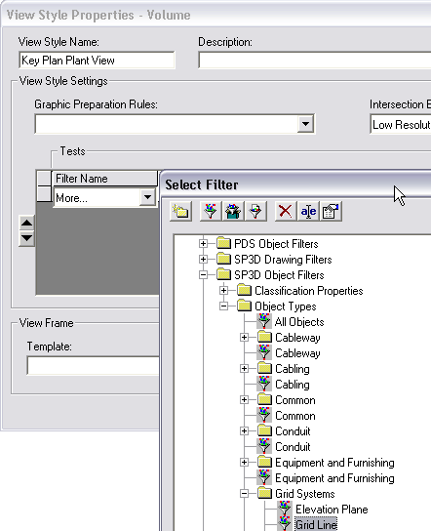
- Select Normal Gray for the graphic rule
- In the second row, enter ‘KEY_PLAN_FOCUS_ELEMENT’ in the filter column
- Select Blue as a graphic rule

Creating a volume drawing package

A. Creating the package
- Right-click on the plant and create a folder called Packages
- Right-click on Packages and add a New Volume Drawings component
- Rename New Volume Drawing to Piping1
- Right-click on Piping1 and Edit Template
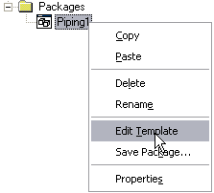
- Select Imperial\D Wide Note Area and click OK.
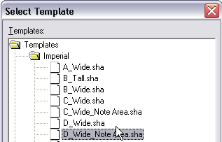
- Maximize and fit the view in the Drawing Editor
- Select the line at the top of the border till a quick pick is shown, using it select the symbol. Watch the attribute viewer on the right side of the Drawing Editor, it will show information when the symbol is selected.
- Right-click on the symbol and select Single View
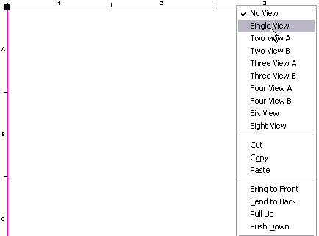
- In the Attribute Viewer, set the Margin Offset to 3” and watch the view resize itself.
- Use the Place Drawing view command to draw the 2D view coincident with the view shown.
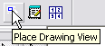
- Fill in the Drawing View Properties as shown
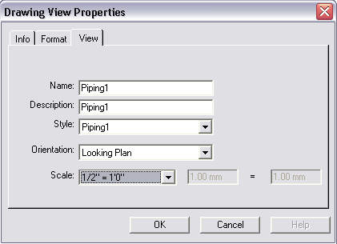
- Switch to the Format tab and uncheck the Show Border box
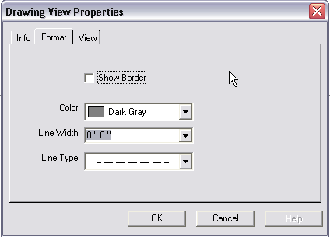
- Now you may select the symbol (using quick pick) and delete it using the delete key. Its only function was to let you quickly place a correctly sized view.
- Close the drawing editor and say Yes when prompted to save.
- Right-click on Piping1 and Save Package…
- Fill in values as below
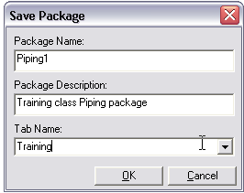
- Now right-click the Piping1 package and delete it.

B. Testing the package
- Right-click on GA Drawings and select New…
- Notice that there is a new tab called Training in the Add Component dialog
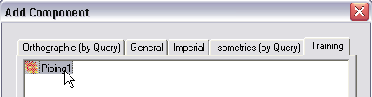
- Select Piping1 and click OK.
- Switch to Space Management task and clear view clipping
- Start the place drawing volume by View command, make sure the ribbon bar shows the Piping1 drawing type selected.
- Place the view where desired using pinpoint if necessary.
- Switch to Drawings and Reports task
- Create and update drawing. Observe that only piping parts that are inside the volume you placed are shown.

Defining Line Styles

- Open the file Styles.sha in the [Symbol Share]\Drawings\Catalog\Templates folder
- Format – Style and pick the Line option and click New
- Name the style Normal Dk Blue
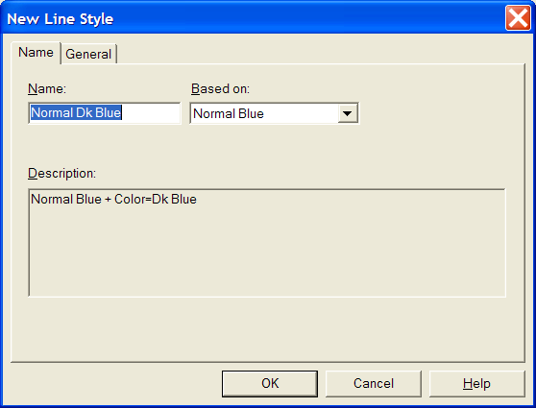
- Change the color to Dk Blue
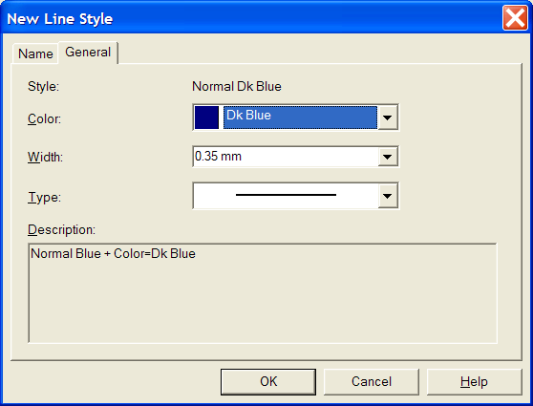
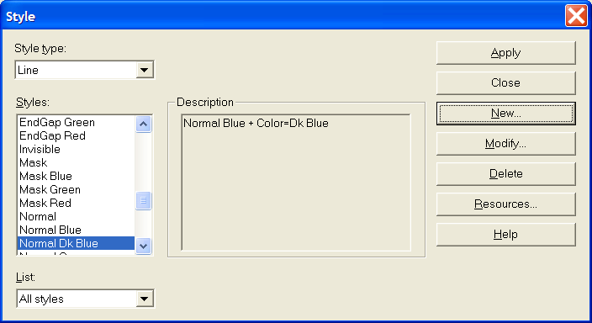
- Close and Save and Exit the Styles.sha file.

Graphic Rules

VHL Rule
VHL Rules simply replace the vector hidden line graphics with a line style chosen from the list of lines in Styles.sha
Define a VHL graphics rule for the Dk Blue line style created above
- Switch to the Drawings and Reports task
- Define View Style and choose the Snapshot View Style Equipment1
- In the Graphic Rule pulldown, select More…
- Click New to create a new graphics rule
- In the Visible Line Style pulldown, select Normal Dk Blue
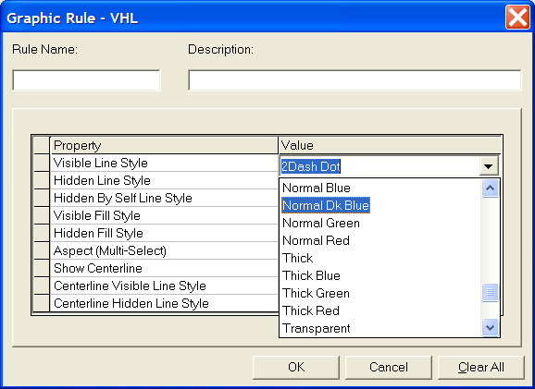
- Click OK to save the new VHL rule.
- Select Normal Dk Blue and click OK to apply it to the view style.
- Click OK to save the view style.
- Click OK to save the Rule.

Replace with Line Rule
This rule merely replaces the representation of the VHL graphics (linear segments) with a line.
- In the Graphic Rule field in the view style, select More…
- In the Graphic Rule type select Replace object with Line
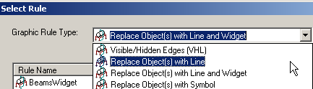
- Create a new Replace with Line Rule named RedLine
- In the Visible Line Style field, select Normal Red
- In the Hidden Line Style field select Dashed Red
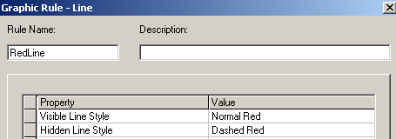
- Save the Rule

Replace with Line and Widget
This rule replaces the object with a line as above. Then it places a widget along the line to represent the cross section of the object. This widget can be either a VHL of the cross section or a externally created symbol.
- In the Graphic Rule type select Replace Objects(s) with Line and Widget
- Create a new Rule named BeamsWidget
- On the graphics tab, select visible line style to be Normal
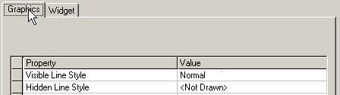
- On the widget tab, select values as below
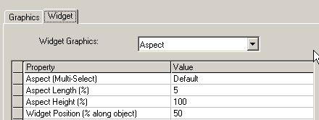
- Click OK to save the rule.

Replace object with symbol
We will create a symbol to use for the replace object with symbol rule first.
- Open the Drawings Editor
- Draw the graphic displayed below (do not include the dimensions). Use a line thickness of 1.0 mm and place it on the Default layer. It is not necessary to have Maintain Relationships set. 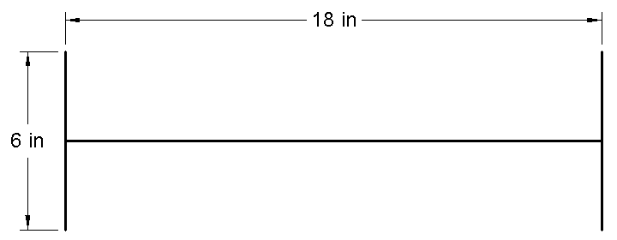
- Select the Select Tool command on the Draw toolbar and drag a fence around the graphics.
- Select the Create Symbol command.
- Left-click at the midpoint on the horizontal line to place the symbol origin. The Save As Symbol box appears.
- Browse to the Symbols share on the server and save the symbol to the [Symbol Share]\Drawings\Catalog\Symbols folder. Name the symbol “W18x35_X_Section”.
- Exit Shape2DServer without saving the document.
- Create a new Graphics rule of the type ‘Replace object with symbol’
- Name the rule Column
- Select the symbol “W18x35_X_Section”.
- Select OK on the Choose Symbol box.
We can now use this rule in a view style to select all columns and replace then with this symbol.

Defining Drawing Labels

Label Template
- Switch to the Catalog task
- Tools – Define Label
- Select the Labels folder and create a new folder named ‘Drawing Labels’
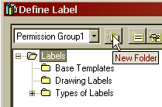
- Select the Drawing Labels folder and pick ‘New COM Label’
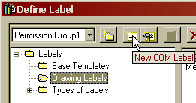
- Name the Label MemberType by typing in the name in the Name field
- Add a property ‘Type’ to the label from the Member Part Prismatic
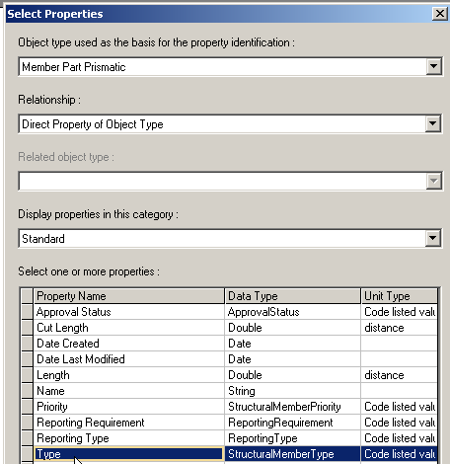
- Select the Type property and insert it to the layout
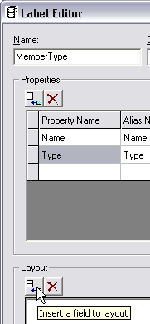
- Similarly insert the Name property
- Click OK to save the label.
- Using Windows Explorer, browse to [Symbols Share]\Labels\Drawing Labels\MemberType and copy all the files.
- Browse to [Symbols Share]\Drawings\Catalog\Labels\Templates and paste the files.

Label Symbol File
- Using Windows Explorer, navigate to the [Symbols Share]\Drawings\Catalog\Labels\Templates folder.
- Copy the SectionSize_None_APO-NL.sym and SectionSize_None_APO-NL.xml files and paste them in the same directory
- Rename them to MemberType.sym and MemberType.xml
- Double-click MemberType.sym to open it
- Double-click the word SectionSize till it highlights in yellow background and then type word MemberType. (This is for your information only, software does not care what text you put here.)
- Right-click the word MemberType and select Properties
- You can change the Border and fill attributes as desired, e.g. choose Border color as Dk Blue and Fill color as Yellow.
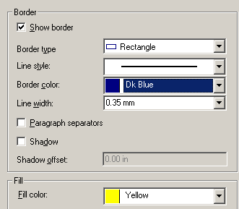
- In the User tab, change Value to MemberType
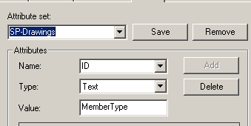
- Click OK and then save the symbol and exit.

Label XML File
- Open the MemberType.xml using NotePad, CookTop or other text editor.
- Scroll down to line 84
<ID attributeName="SectionSize">SectionSize.rtp</ID>
- Change SectionSize to MemberType and SectionSize.rtp to MemberType.rtp
- Edit one of the drawings that contains a Structural Member.
- Start the manually place label command
- Select a structural member.
- Select MemberType from the list of labels
- Click to place

These are the settings that can be set for a label in the XML file:

Name of the label
Name of the label template file and attribute set on the label sym text box
Positioning rules for the label

A | Absolute X and Y location relative to an object.
APO | Absolute X and Y location, parallel, and offset relative to an object.
AV | Absolute X and Y location relative to a vector from the center of the view, and aligned to the object.
CA | Positioned in Clear space by quadrant priority, or positioned in an Absolute X and Y location relative to an object if no clear space is found.
CP | Positioned in Clear space and aligned Linear to the coordinate system.
CM | in the Margin if no clear space is found.
M | Positioned outside the view in the Margin.

Leader placement rule
L | Leader with no jog
JL | Jogged Leader
NL | No Leader

Creating Label Rule
- Copy \Catalog\Rules\LabelRules\SectionSize_None_APO_NL.xml.
- Paste and rename it as MemberType.xml
- Open the file and change SectionSize_None_APO_NL to MemberType. Now the new label is available as a rule

Custom Graphic Rules
These rules are used to change the 3D geometry that is passed into the VHL routines.

CappedNormalPipe.dll

Applies to: Straight pipe, normal to the view
What it does: Replaces the pipes normal to the view with a cylindrical cap in the center of the length of the pipe
When to use: If open (unclipped) ends of pipe are to be replaced with a symbol

DesignEquipmentPartSeparator.dll

Applies to: Equipment
What it does: Separates equipment into body (first shape placed), shapes, nozzles and parts (child components).
When to use: To label and symbolize nozzles of equipment
How to use: In Graphic Preparation Rules, define a rule that uses Equipment as the filter and apply the DesignEquipmentPartSeparator.dll to it. Once this is done, you may put a row for Pipe Nozzles in the view style.

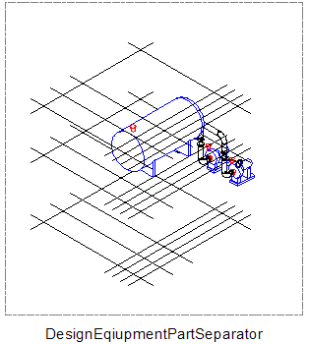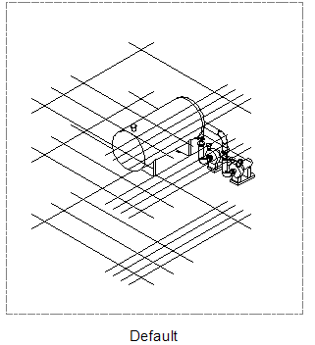

ElbowtoArc.dll

Applies to: Piping Elbows
What it does: Replaces 3D elbow with an arc for the body and two discs for the two ports
When to use: When piping elbows are to be represented as single line but the ends of piping are to be shown.
How to use: In Graphic Preparation Rules, define a rule that select piping components and apply the ElbowtoArc.dll to it.

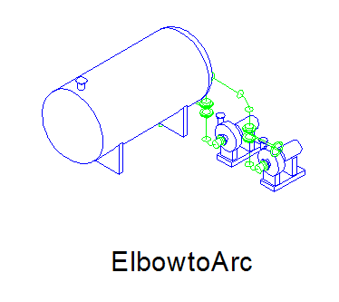

ElbowtoSingleArc.dll

Applies to: Piping Elbows
What it does: Replaces 3D elbow with an arc
When to use: When piping elbows are to be represented as single line
How to use: In Graphic Preparation Rules, define a rule that select piping components and apply the ElbowtoSingleArc.dll to it.

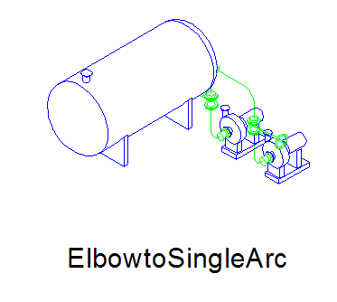

EquipmentNozzleSeparator.dll

Same as DesignEquipmentPartSeparator, but for standard equipment.

GridlinesDrawingWrapperEntity.dll

Applies to: Grid Planes
What it does: Draws ‘vertical gridlines’ at the intersection of X planes and Y planes (on the X-Z and Y-Z axes)
When to use: In elevation and isometric views when drawings need to show vertical lines at grid intersections
How to use: In Graphic Preparation Rules, define a rule that uses GridPlanes as the filter and apply the Gridlines DrawingWrapperEntity.dll to it. Once this is done, you may put a row for Grid Planes in the view style. The graphic rule for the grid planes also needs to include a reference to the GridlinesDrawingWrapperEntity.dll.

MakeDrawable.dll

Applies to: All graphical objects
What it does: Makes objects that are usually not displayable in 3D (hence not drawable in 2D), drawable.
When to use: Whenever you need to label or display objects such as features, runs, systems, pipe support assemblies on a drawing.
How to use: In Graphic Preparation Rules, define a rule that select the objects that are to be made drawable and apply MakeDrawable.dll to them
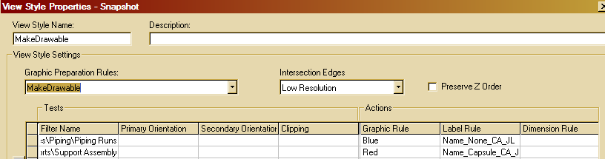

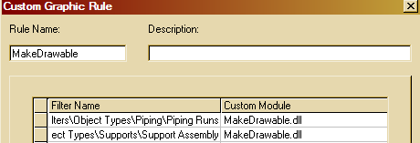

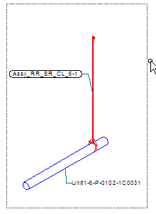

PipeTurnFeattoArc.dll

Applies to: Piping turn features
What it does: Makes the piping turn feature drawable and replaces it with a single arc
When to use: When pipe bends are to be shown as single line.
How to use: In Graphic Preparation Rules, define a rule that select piping turn features and apply the PipeTurnFeattoArc.dll to it.

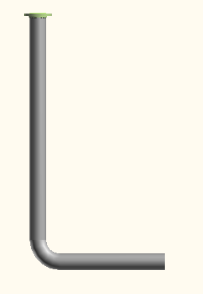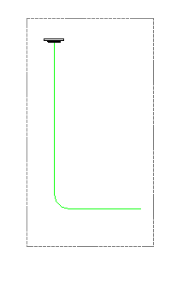

PortsSeparator.dll

Applies to: Piping components
What it does: Separates the ports of the piping components from the component and makes them drawable
When to use: When the open end of an elbow is to be replaced by a symbol
How to use: In Graphic Preparation Rules, define a rule that select piping components and apply PortsSeparator.dll to them. Then in the view styles, use the PsuedoFilter ‘Ports’ as FilterName::Ports and replace with symbol graphic rule.

ReplaceWPoint.dll

Applies to: All graphical objects
What it does: Replaces the 3D geometry of the object with a tiny sphere at the center of the range
When to use: When you need to label an object but do not wish for it to participate in VHL and potentially hide other objects behind it.
How to use: In Graphic Preparation Rules, define a rule that select the objects that are to be replaced with a point and apply ReplaceWPoint.dll to them

SlopedPipeWArcSymbol.dll

Applies to: Sloped straight pipe
What it does: Replaces straight pipe with its centerline and a series of arcs representing the slope
When to use: When sloped pipe is to be represented on a plan drawing

VolumeWireFrame.dll

Applies to: All graphic objects
What it does: Replaces an object with its wireframe representation for VHL
When to use: When you need to show outlines of certain objects and want to keep the objects’ surfaces from hiding other objects
How to use: In Graphic Preparation Rules, define a rule that selects the objects and apply VolumeWireFrame.dll to them.

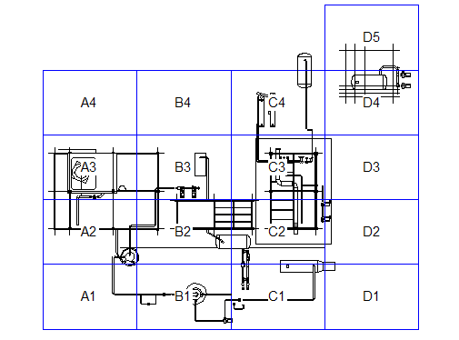

Advanced View Styles
The basic view style consists of several rows each with a filter and a graphic rule. This determines what goes on a drawing and how it looks. Adding labels to the view style can be considered an intermediate operation. The advanced operations consist of additional orientation and clipping tests, custom graphic rules and dimensioning rules.

Deconstructing the piping plan view style
The instructor will lead you through opening a Piping Plan drawing created with the delivered Piping Plan view style and identifying what elements on the drawing are created by which rows in the view style.

Analysis of drawings for view style creation
The following table describes the set of steps required to create a view style to match a drawing standard.

Analysis | SP3D Activity | UI
Read paper drawing to identify items included | Map objects seen on drawing to SP3D object types and match up each kind with a specific filter | Filter UI. May have to rely on SQL filters for certain kinds of elements.
Find out graphical representation in drawing (single line/double line, line style, weight, color etc and all the conditions that prompt that line style to be used). | Decide which graphic rule is to be used for each of the objects identified above. Objects may have to be subclassified based on size, orientation w.r.t paper, clipping conditions etc.  It may be required to use custom graphic wrappers to change the 3D representation of objects to suit the drawing requirements. | Graphic rule UI.  UI exists for creating new line styles.
Find out label annotation required for each and the rules to place the annotation (data reported by the label, position of the label w.r.t the object, leader lines - their styles etc). | Decide what object is labeled with what data and where the data is in the data model. A report label that traverses the relationships will need to be written if required.  Decide which point on the object needs to be labeled (end, center, control point, origin etc).  Decide which positioning modules are appropriate for each label (absolute, parallel, clearspace, margin)  Decide which leader modules are to be used. | UI exists for writing the report label and the look and feel of the label in the sym file.  There is no UI yet for the positioning and leader portions.
Find out dimensioning required for each item type. Dimensioning includes dimension attributes such as units, arrow style etc as well as its position w.r.t object. Since dimensions are always between two things (either parts of the same object or distinct objects), find out how each dimension was placed and what it represents. Dimensions are best of thought of as chains composed of various object types, with some anchoring types (e.g. columns, grids or decks) and other target object types (e.g. equipment, piping etc). | Decide the type of dimension  (only linear currently supported except for penetration plates)  Decide what point of the object the dimension witness lines need to reach.  Decide which positioning modules are appropriate (absolute, clear space, margin)  Decide the direction of the dimension (horizontal, vertical)  Define anchoring elements filters and target element filters. | No UI.

